GIT AND GITHUB

To check git version

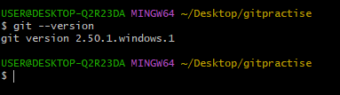

To initialization of git

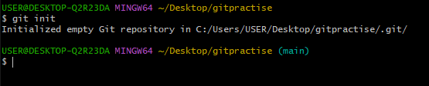

To check hidden directory of .git

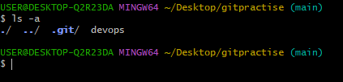

To check status of repo

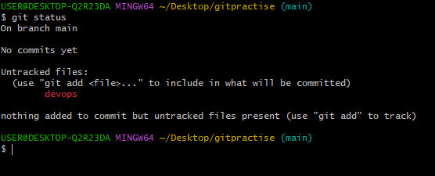

To check the configuration details

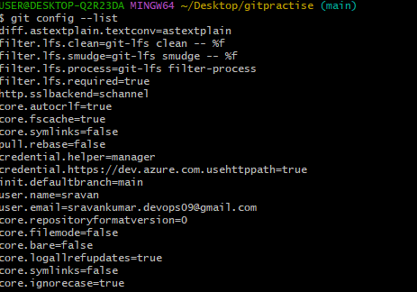

To config username and useremail

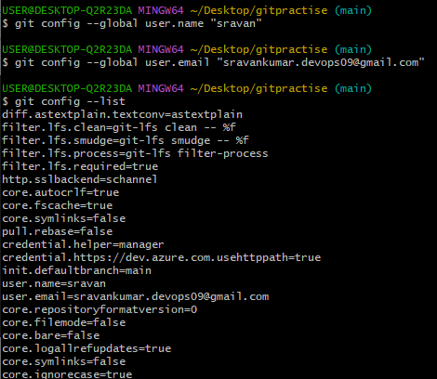

To move untracking area to tracking area

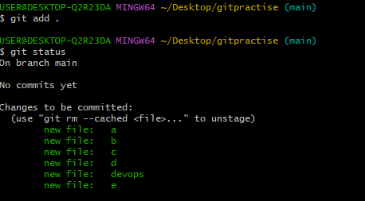

To commit the files in the repo

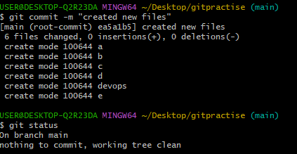

To check logs in directory (whatever the changes )

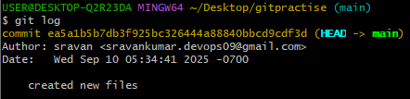

To add central repo url to local repo

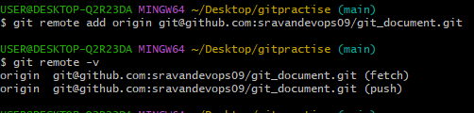

To check the address or destination

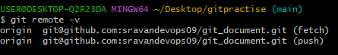

To generate sshkey

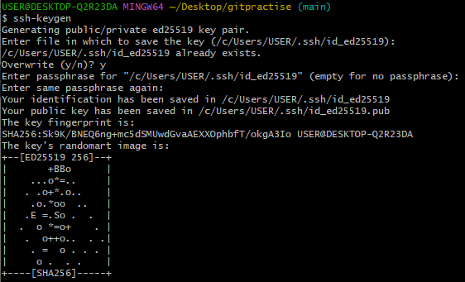

To read the sshkey

Cat /c/Users/USER/.ssh/id_ed25519.pub



How to take pull from central repo to local

Git pull

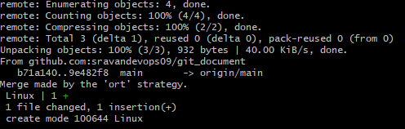

To download complete central repo to local

Git clone path

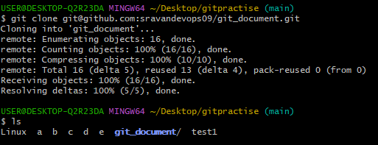

To check the logs or deleted files

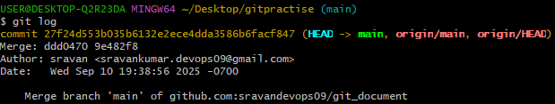

To revert the changes file or deleted file

Git revert commit Id

Change tracking area to untracking area?

